# FB LAUNCH AN INDEPENDENT PLATFORM BULLETIN FOR WRITERS

Suggested Url: <https://www.w3era.com/fb-bulletin-for-writers>



Facebook announced the latest service for writers called Bulletin that will help them connect with, grow and build their audience. 100% of subscription revenues go to the creators.

Bulletin is a standalone website on Bulletin.com. Bulletin.com by Facebook offers websites for writers to engage with and cast their readers, leveraging Facebook to increase their reach.

**FB Bulletin Video URL:**

<https://www.facebook.com/watch/?v=224642666151985>

## What is Facebook Bulletin?

Bulletin is a set of tools to publish a standard website for writers. It aims to process subscription payments and to pull Fb’s social media to more engagements. The service is currently launching in the United States.

During the upcoming year, more enhanced features and devices will roll out.

**According to Facebook's Announcement:**

**“Through Bulletin, we want to support these creators, and unify our existing tools with something that could more directly support great writing and audio content — from podcasts to Live Audio Rooms — all in one place.**

**We respect the work of writers and want to be clear that anyone who partners with us will have complete editorial independence.”**

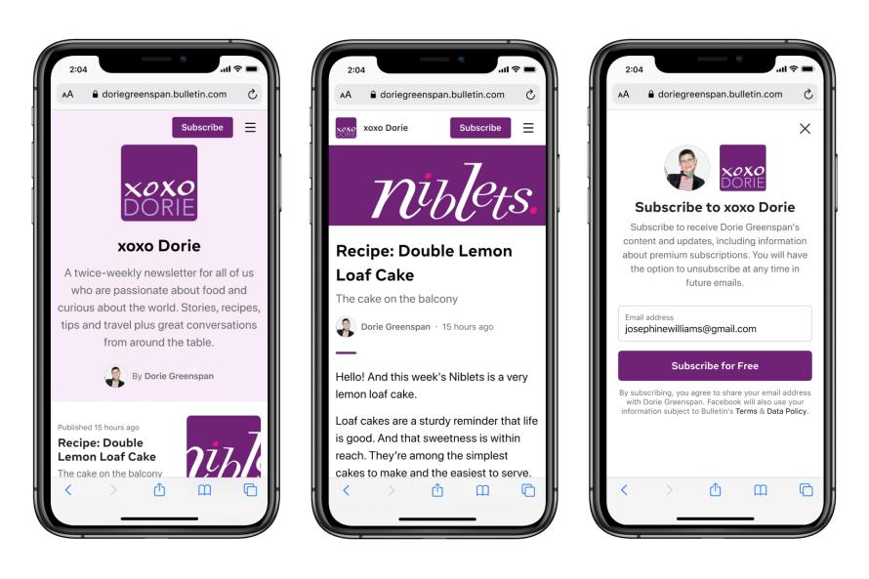

Facebook is setting a lot of emphasis on the writers’ editorial independence as they force people’s concern over what information and content Facebook will claim for itself.

The bulletin also tries to become a podcast to follow their platform as well. Their announcement states Bulletin will early cover tools that allow the distribution of podcasts, including those that are hosted remotely with additional audio features that remain undefined for now.

## Facebook Bulletin Tools

Bulletin is an innovative service features tools that improve content creation, monetizing, and growing the audience.

The Key Features include:

1. **Robust Publishing Devices:**

These building tools enables creators to begin their own publications and record long-form features.

* Each Bulletin creator will have a standalone [website](https://www.w3era.com/web-development-services/) supporting their own brand and will be ready to customize their publication’s name, logo, and color palette.
* Creators can customize their articles with multi-media embeds & distinct styling choices.

1. **Sustainable Business Forms:**

Bulletin requires creators to build sustainable independent businesses on their own courses.

* The bulletin offers writers 100% of subscription revenue and portability of content and email lists. Subscription payments will be securely manipulated by Facebook Pay, permitting subscribers to pay with a credit card, debit card, or PayPal account.
* Bulletin also has analytic tools to support writers, understand their audience and develop their subscribers over time.

1. **Discovery and Distribution:**

Bulletin needs to join audiences with a wide range of new and diverse voices and enable them to go deeper into the problems they consider about.

* Bulletin content will be available for distribution in FB News and other discovery coverings to help audiences quickly find it and subscribe.
* The bulletin will blend with Facebook Pages to allow publishing across multiple multimedia formats.

Want to Free Website Audit Report, Click Here: <https://www.w3era.com/website-seo-analyzer/>

1. **Building Community**

Bulletin writers will have an opportunity to promote wider connections with their audiences on Facebook.

* Writers will have the knowledge to leverage Facebook’s existing tools, like Fb Live or Live Audio Rooms to extend the analysis with their associations.
* The bulletin offers comment moderation tools to assist writers in continuing discussions.

Facebook Bulletin proceeds with other [Facebook](https://www.w3era.com/facebook-advertising-services/) tools that assist creators. Rather than rely on third-party content outside of Facebook, Facebook is creating an ecosystem that generates content that is native and exclusive to Facebook.

If you’re interested in earning subscriptions to your audience and are watching for a hub for your content then focus on how the platform will improve and grow.

**Reference of the announcement of Bulletin by Facebook:**

<https://about.fb.com/news/2021/06/introducing-bulletin-a-platform-for-independent-writers/>

**More related blogs on Facebook updates:**

<https://www.w3era.com/fb-latest-ecommerce-features/>

**Vinita Choubisa**

**(Digital Marketing Executive)**